Ra

Geb and Nut

Shu

Osiris

Isis

Set

Nepthys

Horus

Bast

Serqet

Anubis

Bes

Nekhebet

Babi

Tawaret

The Avenger God

God of Storms and Evil

Goddess of Cats

God of the Sun

God of Dwarves
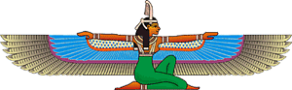
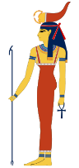
God of the Underworld

Goddess of Vultures
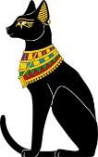
Goddess of Hippos
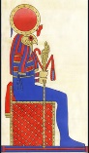
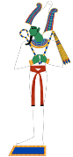
God of Earth and Goddess of Sky

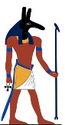
God of Air

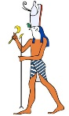
Goddess of Magic

The River Goddess
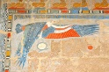
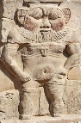
God of Funerals

Goddess of Scorpions
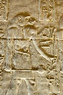
God of Wild Baboons
