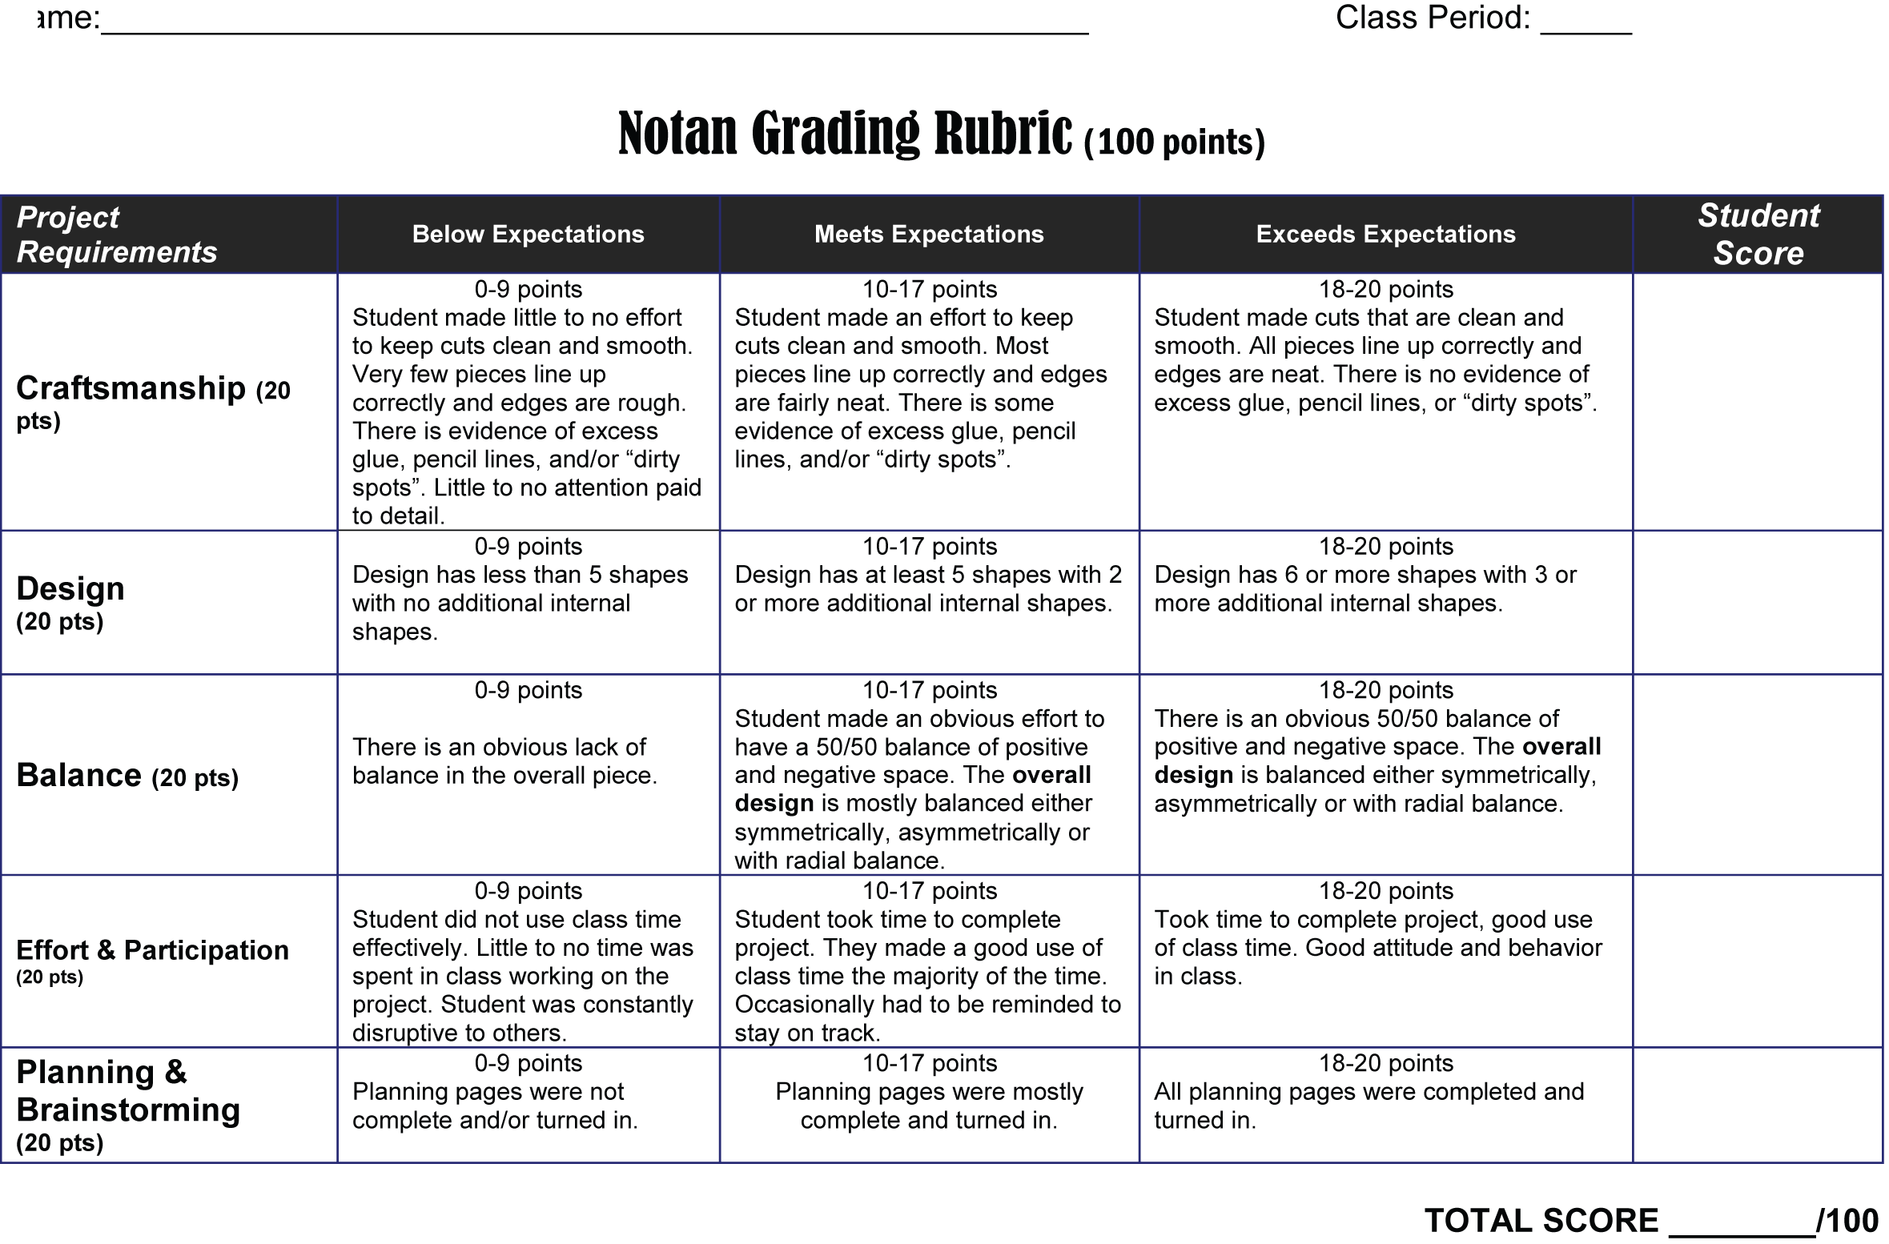
- What is the definition of a Notan?

- Do you think your final Notan is successfully balanced between dark and light? Is your balance symmetrical, asymmetrical, or radial? Explain.

- If there is one thing you could do to make your Notan even better than it already is what would it be?

- What was the hardest part in creating your Notan?

- We used positive and negative space a lot with this project. What other Elements of Art did you use to help complete this project? Explain how you used it.

