Perspective Box Drawings
- Choose one of the 2 still life’s in the classroom.
- Draw at least 3 separate thumbnails to figure out composition and practice perspective.
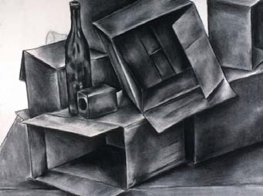
  - Your drawing should be in 2 point perspective.
  - If you wish to challenge yourself sit either above or below the still life to practice 3 point perspective.
- Once you have drawn your thumbnails choose your favorite one and re-sketch it on a separate page.
  - Once you have sketched your final show where you plan to add color.
- When you feel happy with the composition, perspective and color of your drawing start thinking about what you would like to do creatively with your final piece.
  - Example: Is it underwater? Are there fish and coral incorporated? Are there humans rock climbing on it? Are they Christmas boxes? What do the boxes contain? Get creative and have fun.
  - Make a document with AT LEAST 3-6 image references to help you draw your idea. Send it to me and I will print it. They then need to cut out and added to your sketchbook.
- Show me your final plan and image references.
- Once it is approved grab a final piece of paper (10 X 13) and begin drawing your final.

Perspective Box Drawings
- Choose one of the 2 still life’s in the classroom.
- Draw at least 3 separate thumbnails to figure out composition and practice perspective.
  - Your drawing should be in 2 point perspective.
  - If you wish to challenge yourself sit either above or below the still life to practice 3 point perspective.
- Once you have drawn your thumbnails choose your favorite one and re-sketch it on a separate page.
  - Once you have sketched your final show where you plan to add color.
- When you feel happy with the composition, perspective and color of your drawing start thinking about what you would like to do creatively with your final piece.
  - Example: Is it underwater? Are there fish and coral incorporated? Are there humans rock climbing on it? Are they Christmas boxes? What do the boxes contain? Get creative and have fun.
  - Make a document with AT LEAST 3-6 image references to help you draw your idea. Send it to me and I will print it. They then need to cut out and added to your sketchbook.
- Show me your final plan and image references.
- Once it is approved grab a final piece of paper (10 X 13) and begin drawing your final.

