Rosetta Stone Worksheet
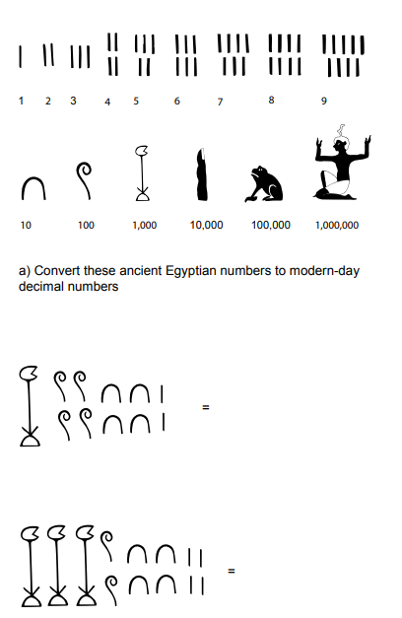
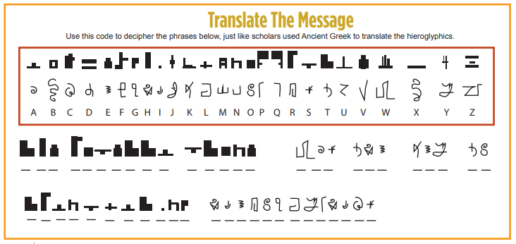
Now convert the numbers: Next, create your own set of hieroglyphs:

A B C D E F

G H I J K L

M N O P Q R

S T U V W X

Y Z

